Call for Special Issue Proposals 2027 for Scientific Studies of Reading
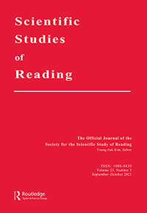

Dear colleagues,

Scientific Studies of Reading is now soliciting proposals for the Special Issue to be published in January 2027.

Recent special issue topics are as follow:
- 2026: Research on Writing Development and Instruction (Guest editors: Steve Graham, Gustaf Skar, and Debra MyHill)
- 2025: Science of Teaching Reading (Guest editors: Young-Suk Kim & Catherine Snow)
We are interested in the topics that will significantly move forward the field, addressing important and relevant issues. Information on the proposals is found in the attached form. Please submit your proposals or any questions to Young-Suk Kim at youngsk7@uci.edu by the November 15, 2024. Submitted proposals will be reviewed by the Publication Committee and the Editor-in-Chief.

Best,

Young-Suk Kim
Editor in Chief, Scientific Studies of Reading

