Call for Associate Editor for Scientific Studies of Reading
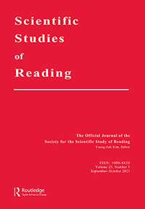

The Scientific Studies of Reading (https://www.tandfonline.com/journals/hssr20) is seeking candidates for the position of an Associate Editor. The Associate Editor’s primary responsibility is the management of the peer review of manuscripts.
Appointment as an Associate Editor will begin on January 1, 2025. A formal application will be due by October 1, 2024.
Qualifications: Candidates should have a record of scholarship as an original researcher on reading and writing research, organizational skills to meet editorial deadlines, the ability to effectively work with other editorial team (editor-in-chief, associate editors, editorial assistant), authors, and the Taylor and Francis management, and excellent oral and written communication skills. Candidates should have a rank of associate professor or higher, or the equivalent within their organization.
Application process: Please submit a current vita and a 1-2 page statement expressing interest and summarizing qualifications along with two to three references who can speak about scholarship and editorial experience to Young-Suk Kim (youngsk7@uci.edu), Editor-in-Chief of the Scientific Studies of Reading, by October 1, 2024. Applications will be reviewed by the current editorial team as well as the Society’s Publications Committee.
Statement of equal opportunity: The Society for the Scientific Studies of Reading is committed to providing an environment of mutual respect where equal opportunities are available to all Society members without regard to race, color, religion, sex, pregnancy (including childbirth, lactation and related medical conditions), national origin, age, physical and mental disability, marital status, sexual orientation, gender identity, gender expression, genetic information (including characteristics and testing), military and veteran status, and any other characteristic. The Society believes that diversity and inclusion is critical to its success as a global society.

